# 题型：阅读+30-40道选择+150字论述+50-60字简答

第一章 Immigration

# 一、Immigration

## （一）Before 1492（Christopher Columbus）

The Indians印第安人（原住民），没有移民

*在哥伦布之前 就有很多推动因素，如：①十字军Crusades东征；②Renaissance文艺复兴；③欧洲封建势力feudalism的衰弱和贸易的兴起；④指南针和印刷技术的发明；⑤绘制地图、探索、海上贸易的兴起…

## （二） Early Immigrants (1492 – late 1700s)

移民：The Spanish, the French, the Dutch, the English….（欧洲移民：西班牙人、法国人、荷兰人、英格兰人）

主导文化the Dominant Culture：盎格鲁撒克逊文化

The WASP（White Anglo-Saxon Protestants新教徒） culture

The English settlers implanted their culture in American soil which was English-speaking, western European, Protestant and middle-class in character. This dominant culture（ also called WASP culture) laid foundation for traditional American values and beliefs. 英国移民把他们的文化植入美国的土地上，这片土地上有说英语的、西欧的、新教的和中产阶级的特征。这种占主导地位的文化(也被称为WASP文化)为传统的美国价值观和信仰奠定了基础。

Therefore, immigrants with these characteristics (white ethnic groups) were welcome (easily assimilated). 因此，具有这些特征的移民(白人族群)受到欢迎(容易被同化)。

There has been a belief that white people are naturally superior to other racial groups which is called ?

White Supremacy白人至上主义（见后，3K党等，杀害黑人）

## （三）the Old Immigrants (early 1800s – 1880)西北欧

移民：The Irish, the Germans, the English, the Scandinavians….（爱尔兰人、德国人、英格兰人、斯堪的纳维亚人）

All of northern and western European origins北部和西部的欧洲人

## （四）The New Immigrants (1880 - 1920)东南欧

移民：The Italians, the Russians, the Poles, the Hungarians…（意大利人、俄罗斯人、波兰人、匈牙利人）

Of southern, eastern European origins南部和东部的欧洲人（和之前的欧洲人在文化上很不相似）

They worried Americans because:

They are so different (language, religion, values)

There are so many of them

### Americanization Movement美国化运动

最早对移民涌入做出反应的是社会改革家，他们发起了“安置屋运动”(Settlement House Movement)。在这个运动中，热心的志愿者住在移民社区，提供广泛的服务，帮助新移民轻松地融入美国社会。相反，美国化运动是由于1917年美国加入第一次世界大战而引起的对外国人的不信任。当美国参战时，美国大约有1300万移民人口和3300万父母是移民的公民。新移民说100多种不同的语言和方言，他们在产业工人中所占的比例越来越大。许多移民都属于根据国家、种族或文化背景而形成的协会，如(希腊)泛希腊联盟和美洲波兰中央救济委员会。政府和工业界的领导人担心这种关系可能会挑战白人盎格鲁-撒克逊社会标准的主导地位，于是开始制定正式的美国化计划。

这一计划既帮助移民工人获得了完全的公民身份，又用保守的美国价值观和理想取代了“旧国家”的传统。国家美国化委员会于1917年5月成立，

Assimilation同化

Enslavement奴役

## （五）The most recent immigrants (WWII - present)西班牙裔和亚洲人

移民：Refugees from WWII and the cold war, the Jews, the Vietnamese…& Hispanics and Asians who have arrived since the 1965 Immigration Law

### 例题

·European immigration to the New world began when the American continent was discovered by __ in ____. The original 17th century settlers were overwhelmingly __. **Christopher Columbus, 1492, English**

·What were the pull and push forces of the early immigration? **Economic, religious and political reasons**

·From early 19th century to 1880, the so-called old immigrants were all of ____ and came in far greater numbers. **northern and western European origins**

·The so-called “new immigrants” refer to the _____ and _____ Europeans between 1880 and 1920. **southern and eastern**

### Hispanics

People of Latin American descent, e.g. Mexicans, Cubans, Guatemalans, Venezuelans…

书上定义A person of Latin American descent living in the U.S. who may be of any race or ethnic group

### 例题

·However, apart from the dominant white population, particularly WASP, most minority groups have been forced into _____ position in almost every category. **inferior**

·Minority groups and their descendants have been suffering from _____, _____ and _____ in this “ allmen-are-created equal” country. **humiliation, discrimination, oppression羞辱，歧视，压迫**

·Asian Americans come in large numbers because of _____. **the 1965 immigration law → (ethnic diversity/ multicultural society)**

·The Largest five Asian American groups in the US are _____________. **Chinese↓, Filipino, Asian Indian, Korean and Japanese**

## 图表

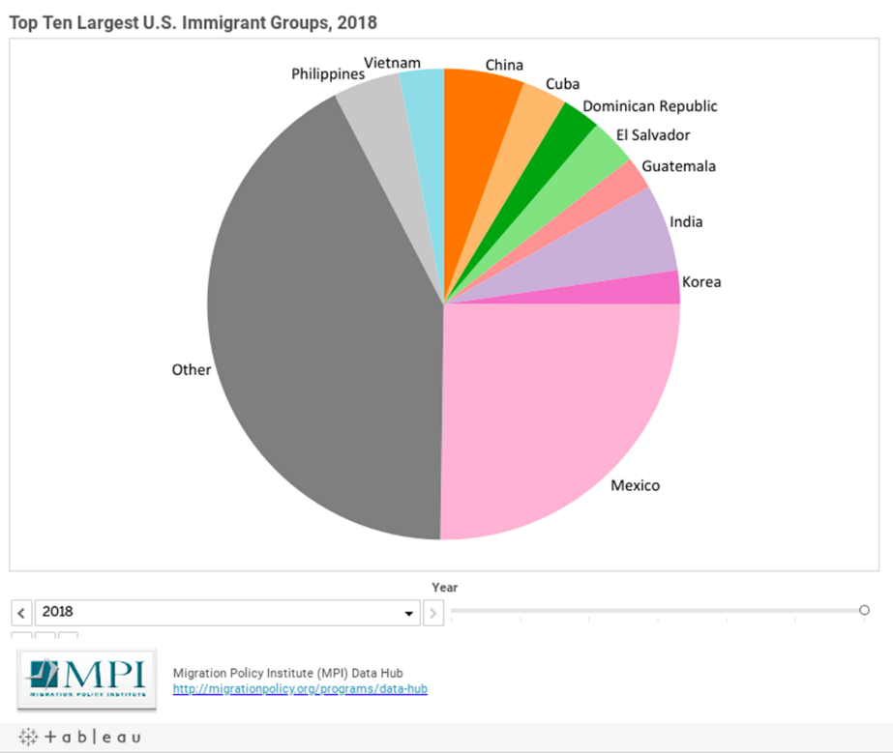

## 种族和民族Racial and ethnic makeup of American population

Racial and ethnic groups in America:

1. 种族Racial

White Americans are the racial majority while African Americans are the largest racial minority.

1. 民族Ethnic

The Hispanic make up the **largest** ethnic minority.拉美民族

### 例题

·In the thirty days between September 15th and October 15th, the United States observes National Hispanic Heritage Month, celebrating the histories, cultures and contributions of those United States citizens whose ancestors came from ____. Spain, Mexico, the Caribbean [ˌkærɪˈbiːən]and Central

and South America**西班牙，墨西哥，加勒比海和中、南美洲**

·Among the Latinos, ____ are the largest and most prominent group, representing more than ___ percent of Latino population in the US, most living in the ____ states. **Mexican Americans, 60, southwestern**

## The push and pull effects of immigration

**Push factors**

Crop failures

religious intolerance/ persecution

Social degradations

political upheavals

**Pull factors**

Economic opportunities (second industrial revolution)

Religious freedom

Social equality

Political stability

# 二、A Brief History of U.S. Immigration Laws

## （一）Unrestricted Immigration: 1492-1870s

Very little restrictions or regulations on immigration对移民很少限制

westward expansion, railroad, oil, California gold rush, crop failures and industrialization in Europe西部大开发、铁路和石油、加利福尼亚黄金热，欧洲种植失败与工业化

## （二）First "Exclusion" Laws and Tighter Control of Immigration: 1880s-1920s

**the Chinese Exclusion Law** (1882) **1882年中国排除法**

Other groups excluded are: criminals, prostitutes, lunatics, anarchists, political extremists, imbeciles, physically and mentally disabled... 其他被排除在外的群体有: 罪犯、妓女、疯子、无政府主义者、政治极端分子、低能者、身体和精神残疾者……

BUT, unprecedented numbers of immigrants came.

deportation驱逐出境

## （三）The National Origins Quota System and End of Anti-Asian Exclusion: 1920s-1964

限制移民的法案：

1921 **the Quota Law**: 3%, based on the 1910 census 1921年**配额法**，1910年人口普查的3% favors European

1924 **the National Origins Act**: 2%, based on the 1890 census 1924年**民族起源法**，1890年人口普查的2%

**WWII and The Cold War:二战和冷战的影响**

more exclusion on political grounds and anti-Japanese;政治上更多限制，反日

ending Chinese Exclusion(1943) and the rise of humanitarian refugee policies1943年结束1882年的中国排除法，人道主义难民政策的兴起

## （四）Family and employment based immigration law: 1965-2000

**the Immigration Act of 1965**: eliminating race or national origin as a basis for denying immigration **1965年移民法**——取消以种族或者国籍作为移民接受标准，转而以家庭、职业作为标准

taking refugees from Vietnam, Combodia and Laos. 接受来自越南、柬埔寨、老挝的移民

## （五）the Linking of Immigration Control to National Security: 2001-Present

9/11, Foreign-born Muslims, Arabs, and South Asians are targeted. 911事件，针对外国穆斯林、阿拉伯人、南亚人

renewed attempts to control unauthorized immigration重新打算限制非法移民

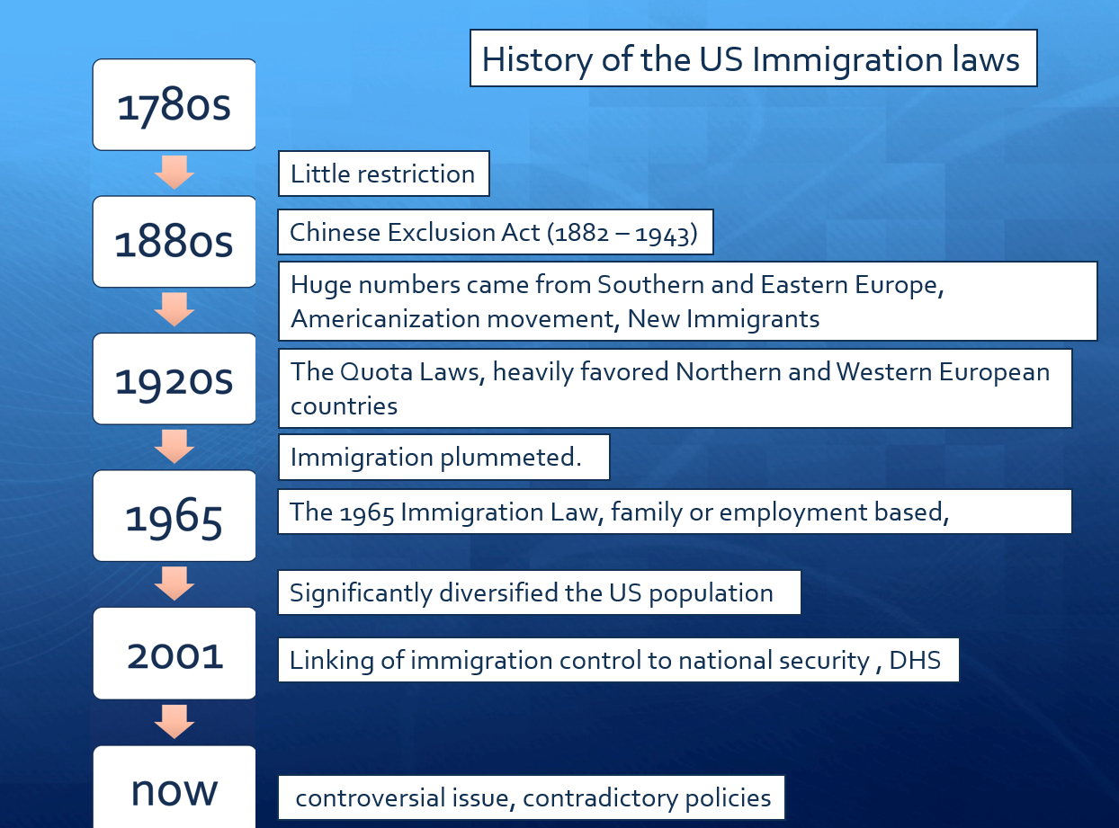

## 例题

·The Immigration Act of 1924: a _____ was established that specified the number of immigrants from each country which heavily favored immigrants from _____ . **quota system, Northern and Western Europe**

·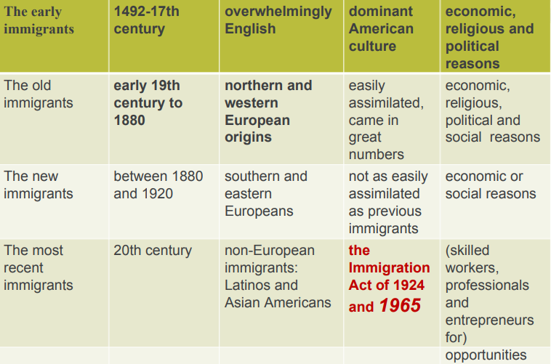

# 三、Multiculturalism / Cultural Pluralism多元文化主义

the idea that people of different races, religions, and political beliefs CAN live together peacefully in the same society and there is strength in diversity.不同种族、宗教、政治立场的人可以在一个社会中和谐共存

Pluralism多元化

# 四、移民原因Why do immigrants move?

## （一）合法移民原因

①To escape: war, famine, persecution, natural disasters….逃避战争、饥荒、迫害、自然灾害

②To get: better paid job, better education, …为了得到工资更高的工作、更好的教育

③Family reunion…..和家人团聚

Excerpt from Declaration of Independence：

" We hold these truth to be self-evident, that all men are created equal, that they are endowed by their Creator with certain inalienable Rights, that among these are Life, Liberty and the pursuit of Happiness."

## （二）非法移民原因——两个政策

### DACA: Deterred Action for Childhood Arrivals(800,000) 童年抵达者暂缓驱逐办法

奥巴马于2012年提出，容许若干在入境美国时尚未满16岁的非法移民申请可续期的两年暂缓遣返，并容许他们申请工作许可。后特朗普取消了DACA，但拜登又恢复了DACA。

### Temporary Protected Status (TPS)临时保护状态（对难民）

Other sources of TPS recipients: Somalia, Sudan, Syria, Yemen…索马里、苏丹、叙利亚、也门

第二章 Racial and Ethnic Minorities

## （一）Racial and Ethnic Minorities

美国人口构成：

60.1%白人，18.5%西班牙裔，12.2%黑人，5.6%亚洲人…

{趋势：西班牙裔占比越来越高}

## （二）Melting Pot

美国就像一个有着共同宗教背景和价值观的文化大熔炉，将各种文化背景、宗教信仰渐渐融入其中。1970s起，美国逐渐有了大熔炉的趋势。

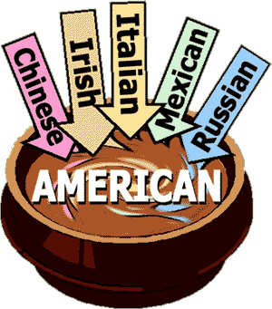

### Chinese Exclusion Act (1882) 1882年中国排除法

In 1889 the Supreme Court upheld the constitutionality of excluding Chinese on the grounds that the Chinese were of a different race, that it seemed “impossible for them to assimilate”, and that they remained strangers in the land, residing apart by themselves, and adhering to the customs and usages of their own country”. If not restricted, this “Oriental invasion” would constitute a “menace to our civilization”.

1889年，最高法院支持排除华人的合宪性，理由是华人是一个不同的种族，“他们似乎不可能被同化”，他们在这片土地上仍然是陌生人，独自居住，并遵守自己国家的风俗习惯”。如果不加以限制，这种“东方入侵”将构成“对我们文明的威胁”。

### Americanization美国化运动

美国化教育运动，19世纪末至20世纪初美国政府发起的旨在使外来移民适应美国社会生活的教育运动。亦称“美国化”。自1900年开始，特别是第一次世界大战后进行征兵检查的结果，表明国外出生而后加入美国籍的第二代英语能力很低，同时，同盟国和协约国两大阵营的对立抗争仍旧发生，导致分裂美国国民的危机。美国化教育运动就是反省这一事实而进行的运动。更具体地说，是以消除居住在美国的外国文盲和对移民进行公民教育为目的，所进行的升国旗和实行美国史教学的教育运动。美国各州先后颁布法令，强调移民儿童必须进美国公立学校接受教育。政府还为成年移民开设夜校英语班。这一运动在不同时期侧重点不同，19世纪末重在教授美国语言，20世纪初则转而向移民灌输忠于政府、遵守法律与社会秩序的思想以及进行美国式价值观的教育。

## （三）Salad bowl

来自几大洲、几大洋的移民人群，几代人还依然保持着他们自己的语言和文化。在从所谓“主流文化”的概念出发考虑对这些人群的接纳或者拒绝问题时，1976年，穆瑞提出，“‘文化熔炉’（cultural melting pot）的概念似乎不适用于他们”，美国已经是一个巨大的 “沙拉碗”。

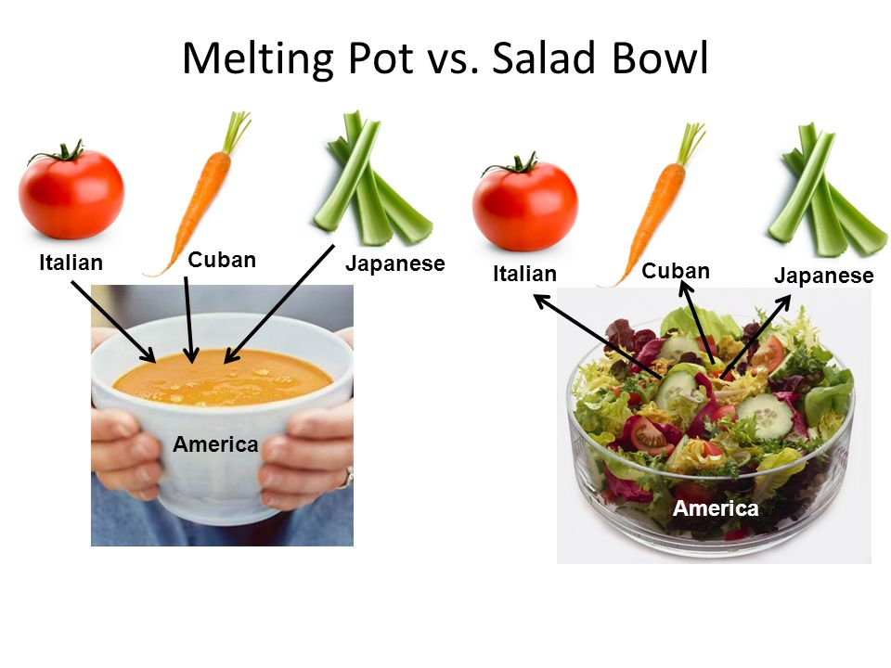

## （四）Mosaic



美国被称为“马赛克”，是因为它是一个多元文化的大国，其中包括不同的族裔、种族、宗教和文化。美国的多元文化使它成为一个复杂而多样的国家，就像马赛克一样，由许多不同的元素组成。

## （五）the African American experience

Slavery- the Civil War- **emancipation（解放）**

**White supremacy：白人至上a belief that white people are naturally superior to other racial groups**

**Crop-sharing system分成制**：分成制是指地主/种植者允许佃户使用土地以换取作物份额的制度。这鼓励了佃户努力工作，尽他们所能获得最大的收获，并确保他们将继续与土地联系在一起，不太可能为了其他机会而离开。

**Disfranchisement** of the blacks (literacy test, poll tax…)：剥夺公民权

**Jim Crow Laws（吉姆克劳法，南方种族歧视）**：1876年至1975年间，美国对黑人实施种族隔离与歧视的法律或制度工具。 该法使黑人在教育、旅游、交通、生活设施与公共场合被隔离，黑人投票权、工作权、受教育权、公平住房权、平等交通权等权利被剥夺。

**Ku Klux Klan（3K党）**

**Segregation种族隔离**

**de jure法律上的（政府）：**直到20世纪最后25年，联邦、州和地方政府的种族明确政策规定了白人和非洲裔美国人应该住在哪里。今天，美国北部、南部、中西部和西部的居住隔离制度，并非个人选择的意外结果，也不是其他善意的法律或法规的意外结果，而是公开的公共政策的结果，这些政策明确地将美国的每个大都市区隔离开来。

**de facto事实上的（私人行为）：**当非洲裔美国人搬到弗格森这样的社区时，一些有种族偏见的白人家庭决定离开，然后随着黑人家庭数量的增加，社区恶化，“白人外逃”随之而来。房地产经纪人让白人远离黑人社区，让黑人远离白人社区。银行以“划红线”的方式进行歧视，拒绝向非洲裔美国人提供抵押贷款，或者在次级贷款中对他们提出异常苛刻的条件。

**Desegregation of Schools (1954)** 1954年废除学校种族隔离

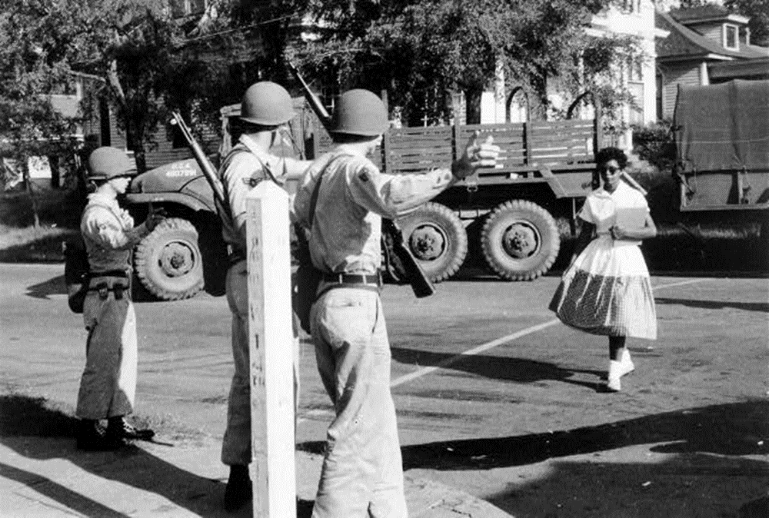

**the Civil Rights Movement(1960s)60年代黑人民权运动**：马丁路德金“I have a dream）

①Achievements:

The Civil Rights Act (1964) 公民权

The Voting Rights Act (1965) 投票权

②Expansion:

Benefited all racial and ethnic minorities其他种族/民族也从中获益

Advanced the rights of women促进女权保护

Strengthened the LGBT community促进LGBT群体保护

③Extension:

Affirmative Action 平权运动

④Results:

A steadily rising black middle class 黑人中产阶级稳定上升

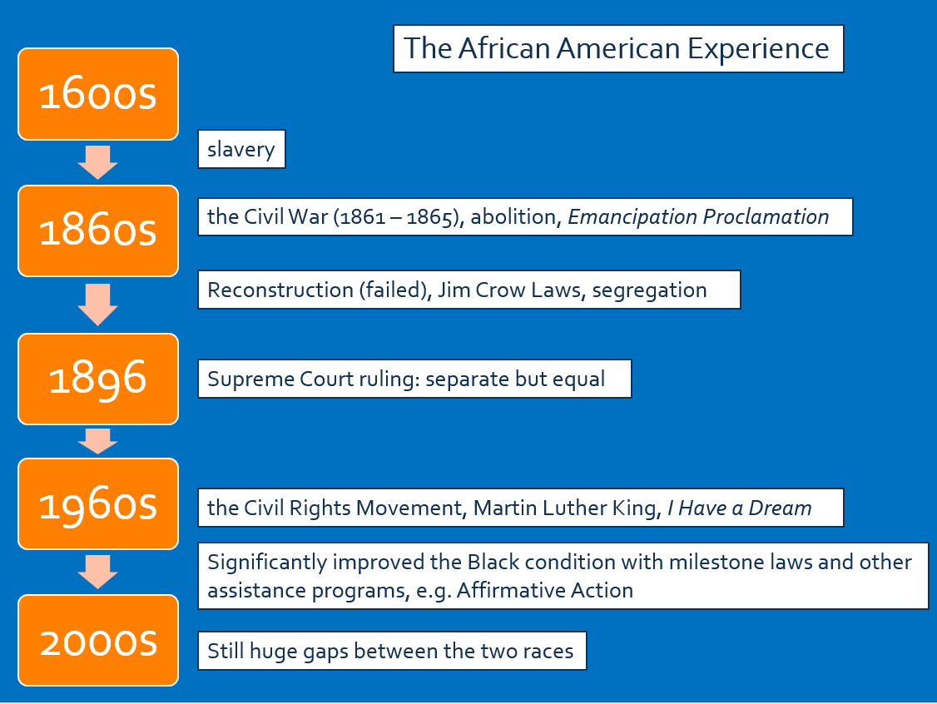

## （六）The growing importance of Latinos

Mexican immigration differs from past immigration in **6 ways**:

1.**Contiguity**临近（来源地紧挨美国）

2. Numbers

3. Illegality

4. Regional Concentration地区集聚

5. Persistence（坚持自己的语言、文化，数量稳定上升）

6. Historical Presence（部分地区本就是拉美人的领土）

What are the 2 things unique to America and Mexico as first and third world neighbors?

1.The US and Mexico have a 2-thousand-mile border marked historically simply by a line in the ground and a shallow river.距离非常近

2.The income gap between the US and Mexico is the largest between any two contiguous countries in the world.贫富差距非常大

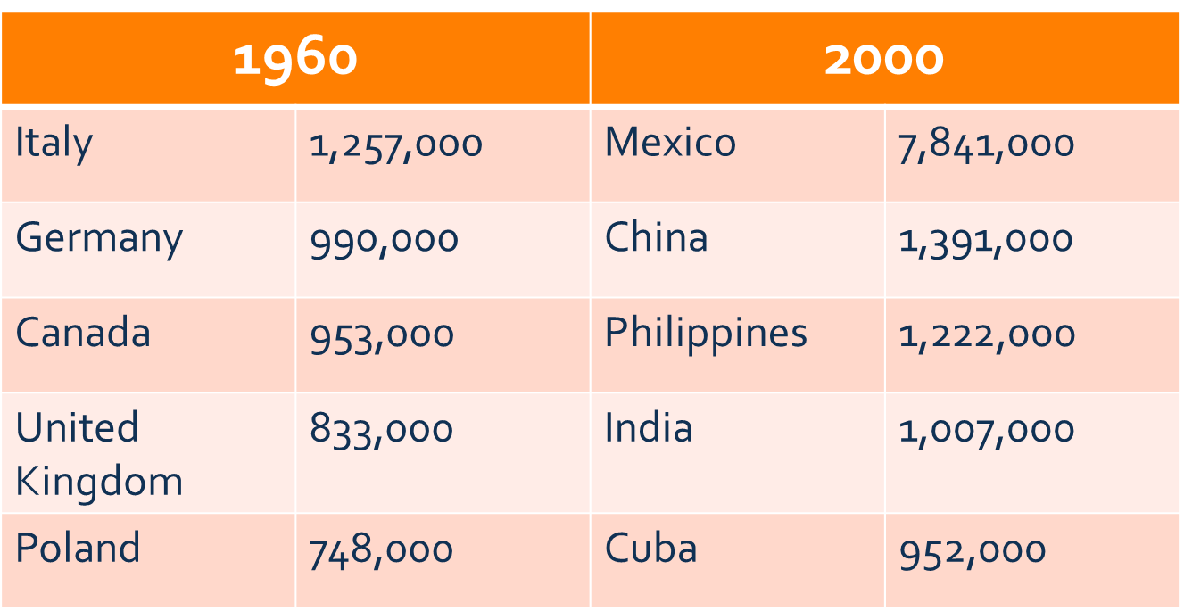

How does **the post-1965 immigration** differ linguistically from previous waves of immigration in history?

In the mid-19th century, immigration was dominated by English speakers from the British Isles. The pre-WWI immigration was highly diversified linguistically. But almost half the post-1965 immigration speak a single non-English language. 在19世纪中期，移民主要是来自英伦三岛的说英语的人。一战前的移民在语言上高度多样化。但几乎一半的1965年后移民只说一种非英语语言。

第三章 American Values and Beliefs

# 一、Individualism / freedom

## （一）What is Individualism / Freedom?

Interests of the individual should achieve precedence over the state or a social group.

Self-expressing individuals

Self-reliance

Resisting control, favoring decentralized, self-government

Not the same as selfishness or egoism

Individualism is a point of view that emphasizes the value of the individual over society. It places more importance on individual dignity and personal interests than on the frameworks of family, community and state. 个人主义是一种强调个人价值高于社会价值的观点。它更重视个人尊严和个人利益，而不是家庭、社区和国家的框架。

By freedom, Americans mean the desire and the right of all individuals to control their own destiny without outside interference from a ruling noble class, the church, or any other organized authority. 美国人所说的自由，指的是所有个人控制自己命运的愿望和权利，不受贵族统治阶级、教会或任何其他有组织权威的外来干涉。

## （二）Limitations of Individualism / Freedom

Freedom is a racialized, sexualized and stratified idea. 自由是一种种族化、性别化和阶层化的概念。

Individual freedom vs. public safety

Individual rights vs. group rights

**Social Darwinism社会达尔文**

# 二、Equality

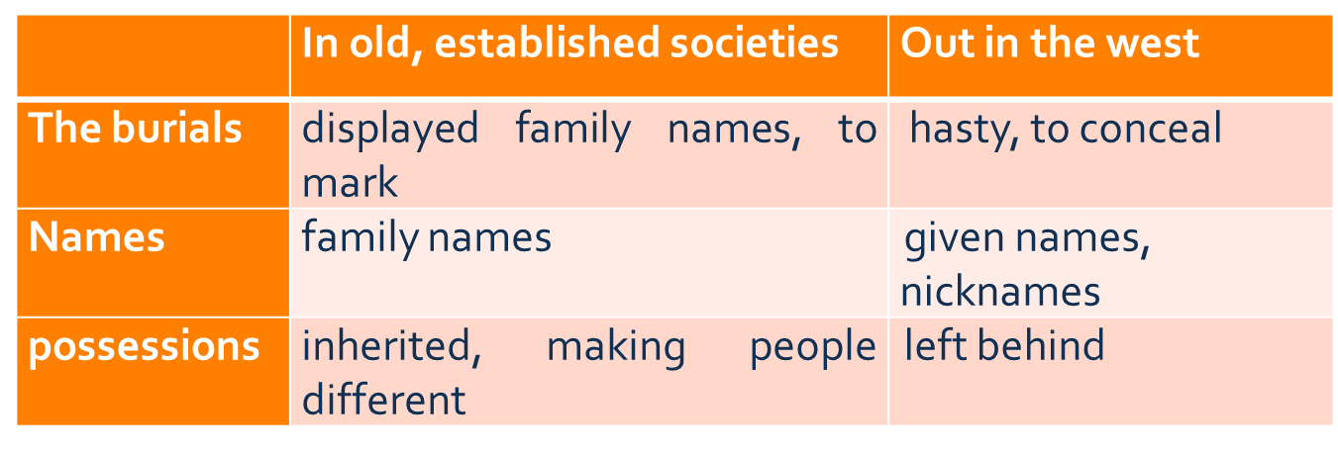

# 三、Wealth Distribution in the US

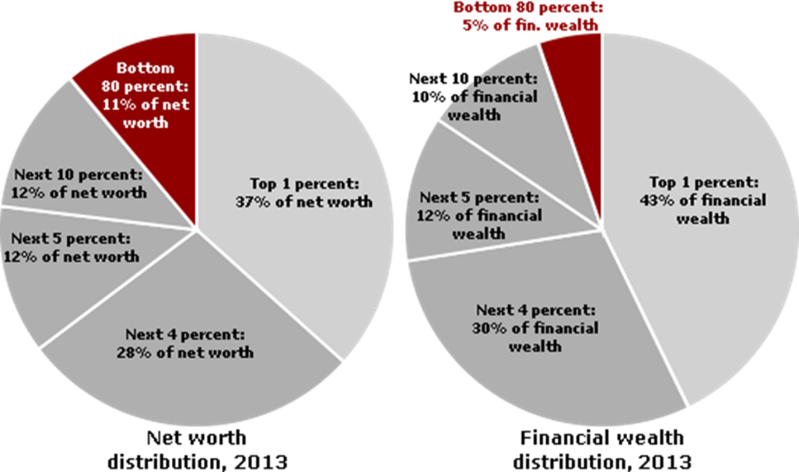

# 四、Equality of Outcome vs. Equality of Opportunity

**Equality of outcome** : measured by whether its citizens generally achieve equal levels of income. 结果平等:衡量标准是其公民是否普遍实现平等的收入水平。

**Equality of opportunity**: measured by whether its citizens generally have the same opportunities to achieve income, emphasizing personal ambition, talent and hard work of the individual, rather than his or her qualities based on membership in a group, such as a social class or race or extended family. 机会平等:衡量其公民是否普遍有相同的机会获得收入，强调个人的雄心、才能和努力工作，而不是他或她的素质基于一个群体的成员身份，如社会阶层或种族或大家庭。

# 五、Why Are People Different?

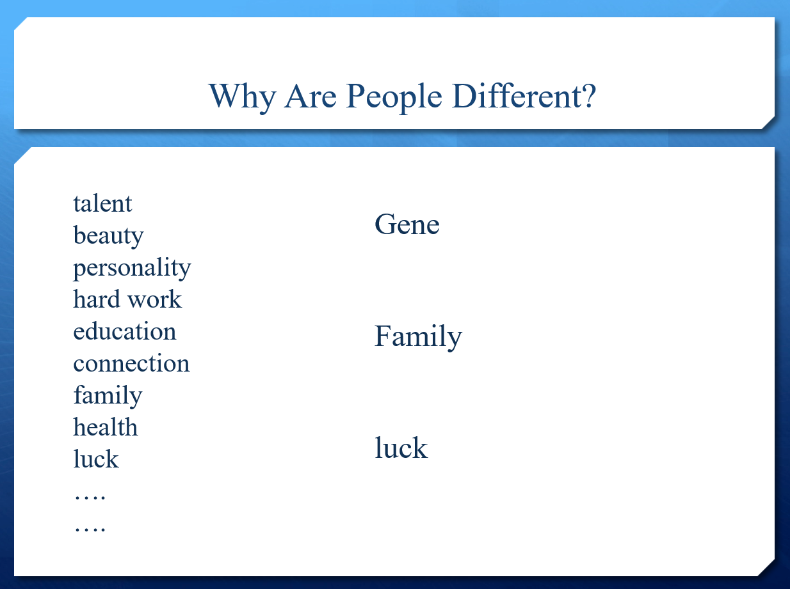

# 六、Individualism and the Work Ethic

工作时间更长等

# 七、Six Basic Values

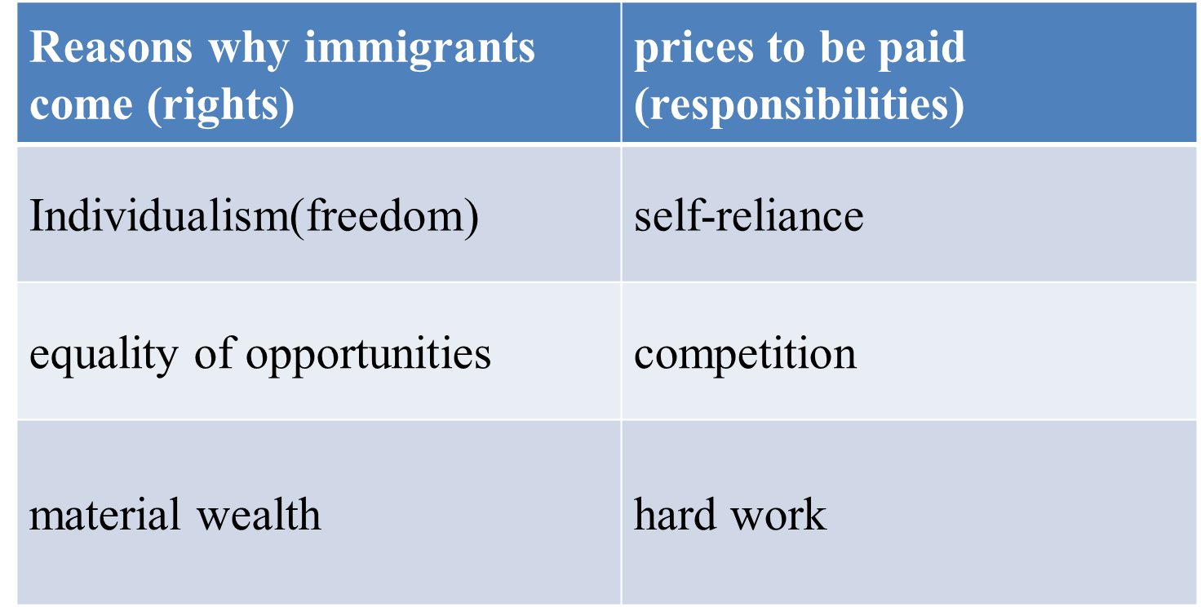

# 八、What is the American Dream?

a happy way of living that can be achieved by anyone in the U.S. especially by working hard and becoming successful.

With good jobs, a nice house, two children, and plenty of money, they believed they were living the American dream.

"life should be better and richer and fuller for everyone, with opportunity for each according to ability or achievement" **regardless of social class or circumstances of birth to achieve prosperity through hard work;**

**Going from rags to riches – quick material success**

## （一）The American Dream in Essence

ANYBODY CAN, regardless of external factors like family, race, religion, gender, etc.

## （二）The American Dream in Crisis

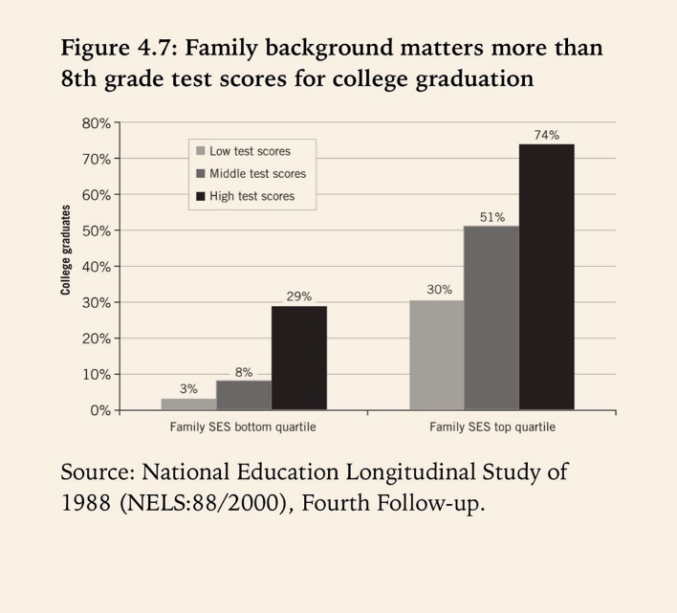

第四章 Religion

# 一、Religion

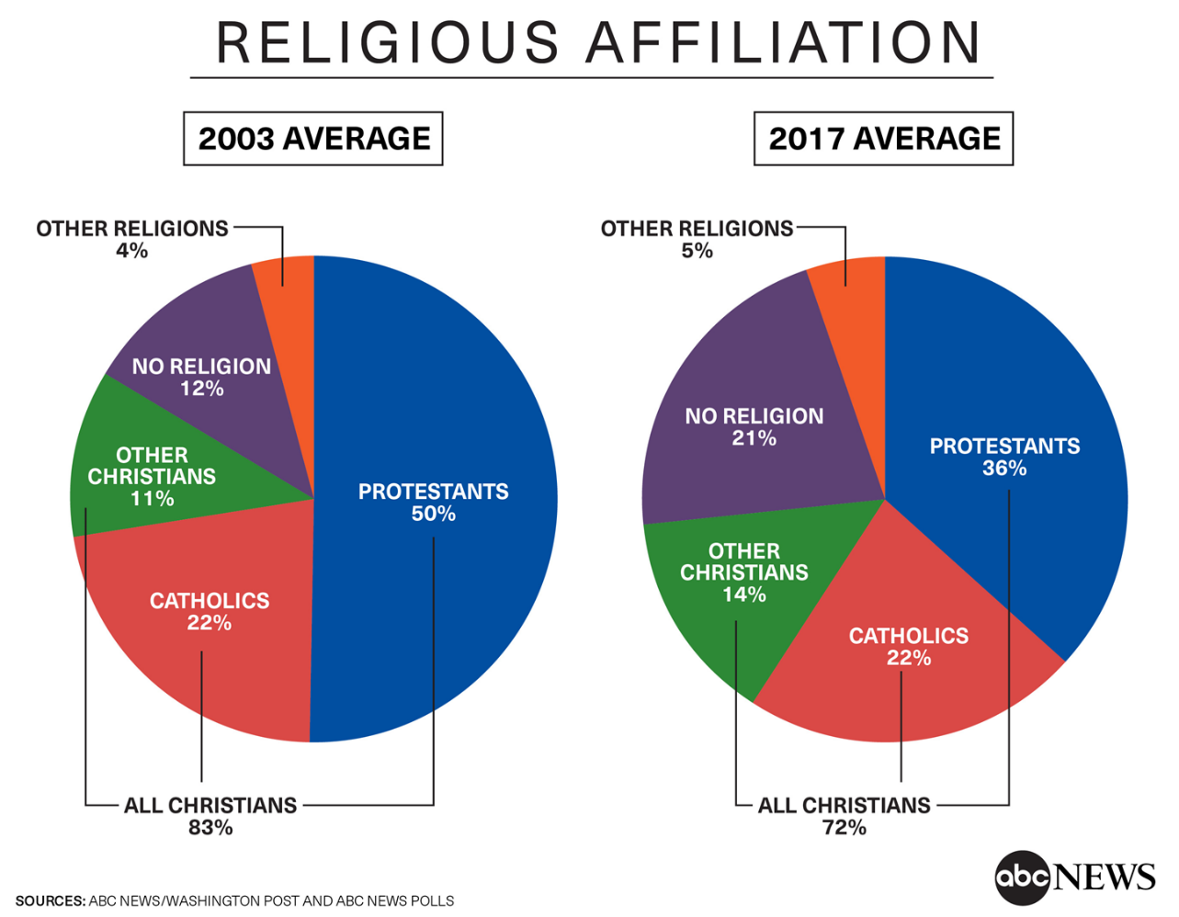

最多的：新教徒（Protestants）

其次：天主教徒（Catholics）、其他基督教徒、无宗教者、其他宗教者

新教徒和天主教徒都是基督徒Christian

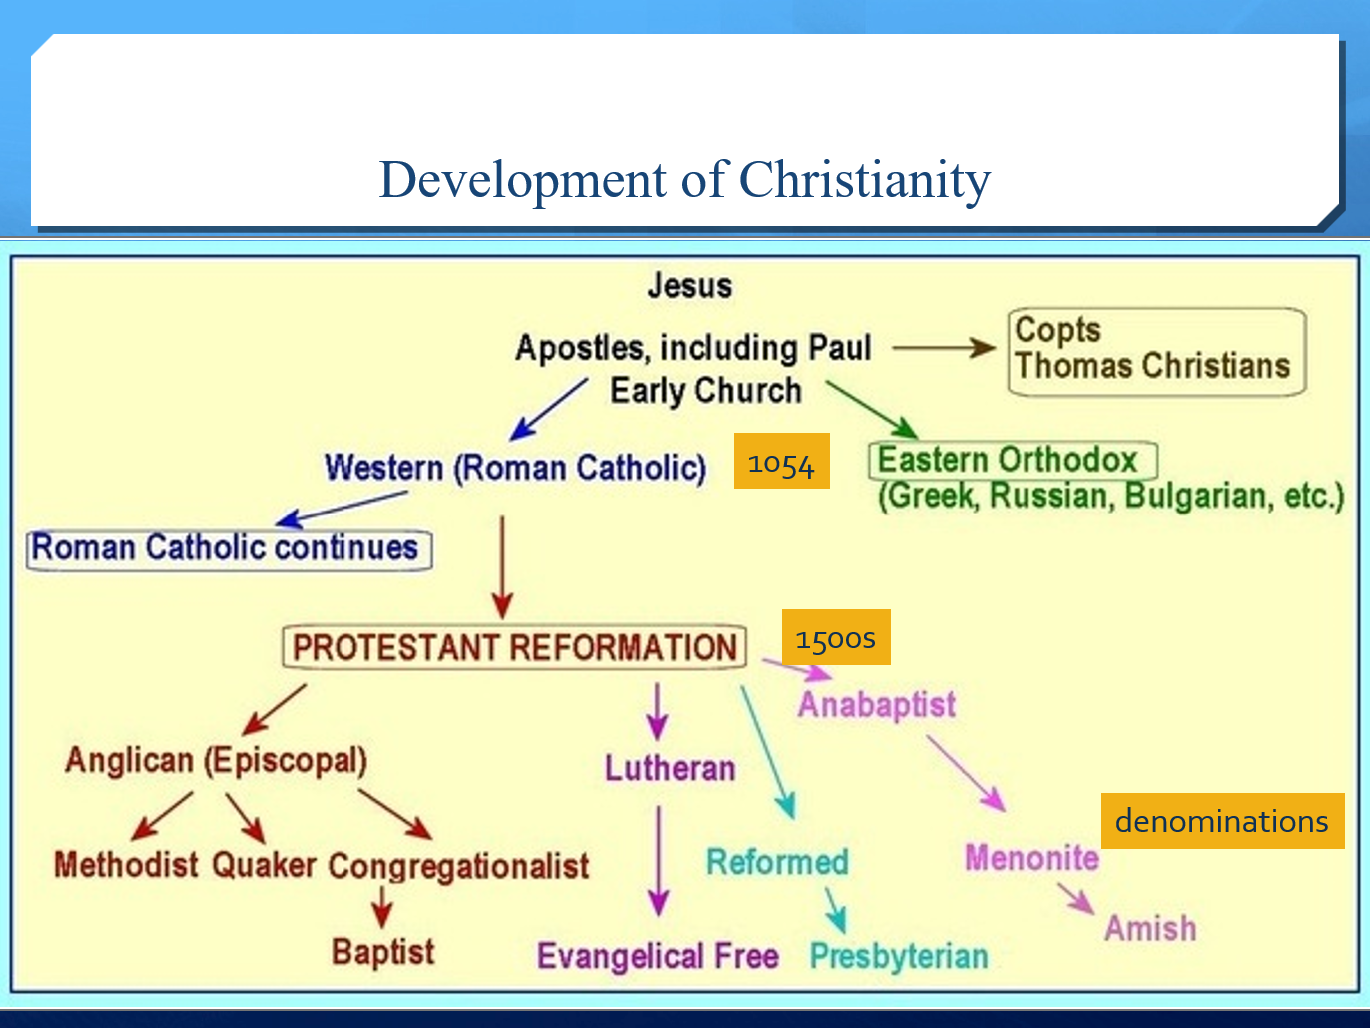

11世纪（1000s）基督教分裂称罗马天主教廷和东正教，16世纪（1500s）罗马天主教中分裂出新教（马丁路德《95条论纲》95 theses）。

1. Supremacy of the Bible信仰的唯⼀根据是《圣经》
2. Justification by Faith Alone因信称义
3. (Universal )Priesthood of All Believers信徒皆为祭司

American-Religious

53% consider religion important

## 二、Religious landscape in the US today

Polarization极化 vs pluralism多元化

## Key points

• Christianity基督教

• Protestantism: Protestant reformation, fundamental principles of Protestantism, major denominations新教:新教改革，新教的基本原则，主要教派

• Roman Catholic天主教徒

• 1st Amendment: religious freedom + separate of church and state第一修正案:宗教自由+政教分离

• Judaism: monotheism犹太教:一神论

• Religious landscape: pluralism and polarization宗教景观:多元化与两极分化

第五章 Ameican Government and Politics

美国的两党：

**1. The Republican Party/Republicans (people)共和党**

AKA ***The Grand Old Party / the GOP***

**2.** **The Democratic Party/Democrats (people)民主党**

**The United States is a federal constitutional republic**

**Basic Principles of American Politics**

**1. Separation of Powers 三权分⽴**

**2. Checks and Balances 制衡原则**

**3. Federalism 联邦制**

# 一、Origin of the Government政府有何权力

约翰·洛克-自由精神

All men were created equal in that all were given by God certain **inalienable**, natural rights (life, liberty, and the right to own property). 人人生而平等，因为人人都享有上帝赋予的某些不可剥夺的、自然的权利(生命、自由和拥有财产的权利)

Legitimate political authority must be based on the consent of the governed. (social contract theory). 合法的政治权威必须以被统治者的同意为基础。(社会契约理论)。

All legitimate political authority exists to preserve and protect these natural individual rights and should limit itself to that purpose.所有合法的政治权威的存在都是为了维护和保护这些自然的个人权利，并应限于此目的。

# 二、1787年《宪法》

The Constitution is broken into three main sections.

The men of 1787 assumed that they were devising a constitution which would endure, but they also recognized that there might be a need for altering it, and they included provisions for amendment. The fifth article lays down the procedure for amendment. The first ten amendments were made almost at once(1791), and they form the “bill of rights”.

宪法分为三个主要部分。1787年的人们认为他们正在设计一部可以持久的宪法，但他们也认识到可能需要修改它，他们包括了修正案的条款。第五条规定了修正的程序。最初的十项修正案几乎是同时制定的(1791年)，它们形成了“权利法案”。

Basic Ideas of the Constitution

1. Popular Sovereignty民众主权

2. Limited Government有限政府

3. Federalism联邦制

4. Separation of Powers三权分立

5. Checks and Balances制衡原则

### Preamble序言

Explains why the Constitution was written：

We the People of the United States, in Order to form a more perfect Union, establish Justice, insure domestic Tranquility, provide for the common defence, promote the general Welfare, and secure the Blessings of Liberty to ourselves and our Posterity, do ordain and establish this Constitution for the United States of America. 我们美利坚合众国的人民，为了建立一个更完善的联邦，确立正义，确保国内安宁，提供共同防御，促进全民福利，并确保我们自己和我们的子孙后代享有自由的祝福，特为美利坚合众国制定本宪法。

**We：**white, male, upper middle class, educated彰显人民在宪法中的绝对地位

The black were given the voting right in 1870 (15th Amendment); Women in 1920 (19th Amendment); The poor in 1964 (24th Amendment)

### Articles (7)正文

Describe how the government works （Articles 1-4) and how the Constitution can be changed (Articles 5) .

Only through Amendments

Passed by 2/3 majority in both houses

Ratified by ¾ of the states

只有通过修正案 两院三分之二多数通过 四分之三的州批准

第一章对国会的组成、职能、权力以及国会议员的选举做了规定；（立法）

第二章对总统、副总统的职权、选举方式做了规定；（行政）

第三章对最高法院及司法机构的组成、权职做了规定。（司法）

第四章厘定了联邦与州的关系；

第五章规定了修宪程序；

第六章确定了宪法的最高权威以及承诺宪法成立前订立的债务及义务依然有效；

第七章规定宪法成立必须得到9个州的批准。

国会：

1.参议院Senate

每个州*2 任期六年（每隔一年选1/3）年满30岁，成为美国公民9年，不是选举州居民 合众国副总统应为参议院议长，但无表决权，除非两人票数相等。

参议院拥有审理所有弹劾案的唯一权力。为此目的开庭时，他们应宣誓或确认。美国总统受审时，由首席大法官主持；未经出席会议的议员的三分之二同意，不得对任何人定罪。

2.众议院House of Representative

基于各州的人口 每两年选举一次 年满25岁，成为美国公民7年，不是被选举州居民 每十年人口统计一次 众议院应选举议长和其他官员；并拥有唯一的弹劾（impeach）权。

House members are elected by voters in congressional districts.

When the first Congress met in 1789, it had 65 members who represented districts of no more than 30,000 people. The House added members throughout the 19th century as the country’s population grew and new states were admitted. A 1911 law fixed the size at 435 members. Today each House member represents about 650,000 people.

House seats are divided among the states by population in a process known as apportionment. After every ten-year national census, the U.S. Census Bureau uses a mathematical formula to assign a specific number of representatives to every state.

Each state is guaranteed at least one House seat, and seven states—Alaska, Delaware, Montana, North Dakota, South Dakota, Wyoming, and Vermont—have only one.

There are also five nonvoting delegates who are elected from parts of the United States outside of the 50 states. These delegates represent American Samoa, the District of Columbia, Guam, Puerto Rico, and the Virgin Islands of the United States. They participate in debate but do not vote. 众议院议员由国会选区的选民选举产生。

1789年第一届国会开会时，有65名议员，他们代表的地区不超过3万人。在整个19世纪，随着国家人口的增长和新州的加入，众议院增加了议员。1911年的一项法律规定，参议院的人数为435人。今天，每个众议院议员代表大约65万人。

众议院席位在各州之间按人口分配，这一过程被称为分配。在每十年的全国人口普查之后，美国人口普查局使用一个数学公式为每个州分配特定数量的代表。

每个州保证至少有一个众议院席位，而阿拉斯加州、特拉华州、蒙大拿州、北达科他州、南达科他州、怀俄明州和佛蒙特州这七个州只有一个席位。

还有五名无投票权的代表是从美国50个州以外的地方选举出来的。这些代表代表美属萨摩亚、哥伦比亚特区、关岛、波多黎各和美国维尔京群岛。他们参加辩论，但不投票。

众议院和参议院通过的每一项法案，在成为法律之前，应提交给美国总统；如果他同意，他将在上面签字，如果不同意，他将把它连同他反对意见一起退回给最初提出反对意见的议院，议院将在他们的议事录上详细记录这些反对意见，并着手重新审议。如果经过重新审议后，该院三分之二的议员同意通过该法案，则该法案应与反对意见一起送交另一院，由该院重新审议，如果该院三分之二的议员同意，该法案即成为法律。但在所有这种情况下，两院的投票应由赞成票和反对票决定，投票赞成和反对该法案的人的姓名应分别记入两院的议事录。如果任何法案在提交给总统后十天内(星期日除外)未被总统退回，该法案应视为法律，如同总统已签署该法案一样，除非国会因休会而阻止其退回，在这种情况下，该法案不应成为法律。

### Amendments 27条修正案（任何修宪案都要得到四分之三个州的批准）

Describes the rights of the citizens of the United States

The first 10 Amendments – the Bill of rights （1791）

描述美国公民的权利 前十条修正案-权利法案(1791年)

The Constitution is broken into three main sections.

The men of 1787 assumed that they were devising a constitution which would endure, but they also recognized that there might be a need for altering it, and they included provisions for amendment. The fifth article lays down the procedure for amendment. The first ten amendments were made almost at once(1791), and they form the “bill of rights”.

宪法分为三个主要部分。1787年的人们认为他们正在设计一部可以持久的宪法，但他们也认识到可能需要修改它，他们包括了修正案的条款。第五条规定了修正的程序。最初的十项修正案几乎是同时制定的(1791年)，它们形成了“权利法案”。

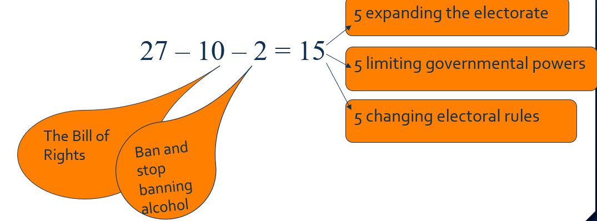

其他15个修正案里，有5个直接涉及选举权的扩大（expanding the electorate）：

1870年将选举权扩大到各个种族（15修正案），

1920年女性选举权（19修正案），

1961年哥伦比亚特区居民选举权（23修正案），

1964年禁止以未缴税为由剥夺公民选举权（24修正案），

1971年将选举权从21岁降到18岁（26）。

另外有5个涉及对政府权力的限制（limiting government powers）。剩下的几个修正案则涉及选举制度（changing electoral rules）。

### 例题

·American constitution is the _______.It includes the ___, 7____ and 27___. **shortest and oldest written constitution still in use. preamble, articles, amendments.**

# 三、Principles

Rule by law 依法治国

Popular Sovereignty人民主权

Separation of Power三权分立（孟德斯鸠、约翰洛克）

Judicial Review司法审查

Civilian Supremacy in Military Matters军民至上

Protection of Individual Rights个人权利保护

Federalism联邦制

# 四、Supreme Court

Eight Justices and one Chief Justice

Appointed by the President and approved by the Senate

Appointed for life

as long as they want（usually 30 years）

”good behavior”

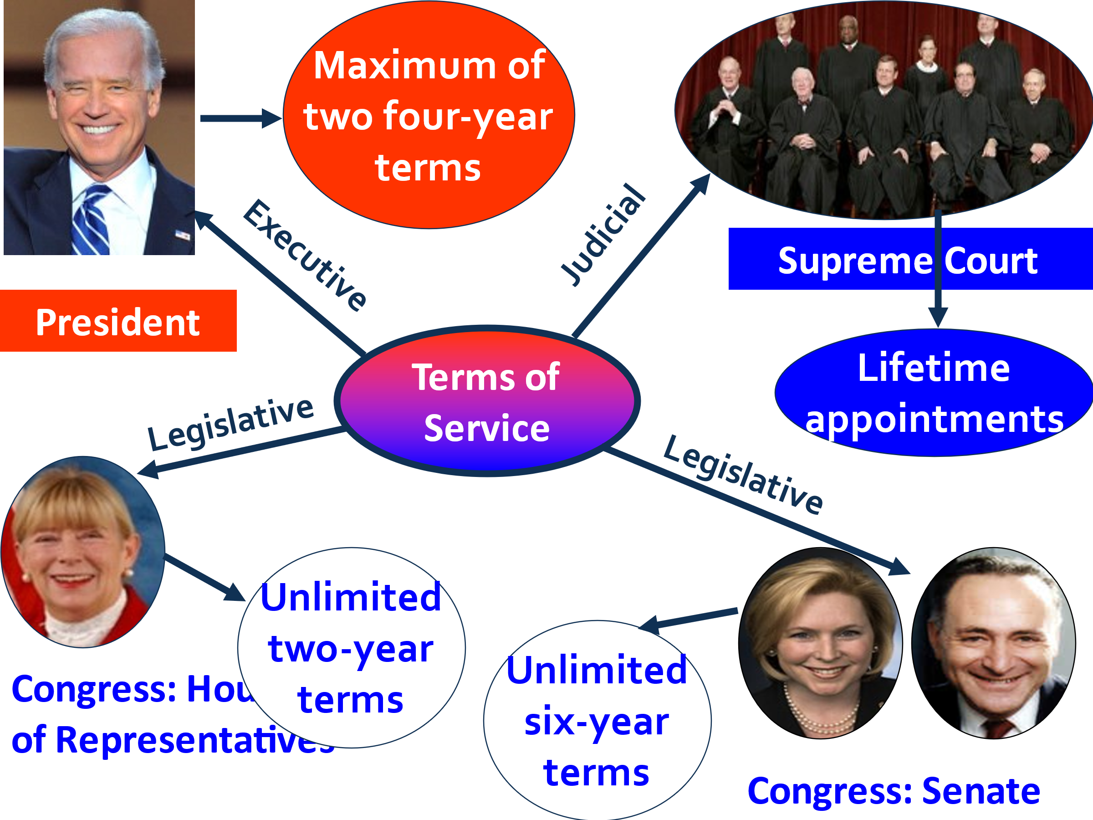

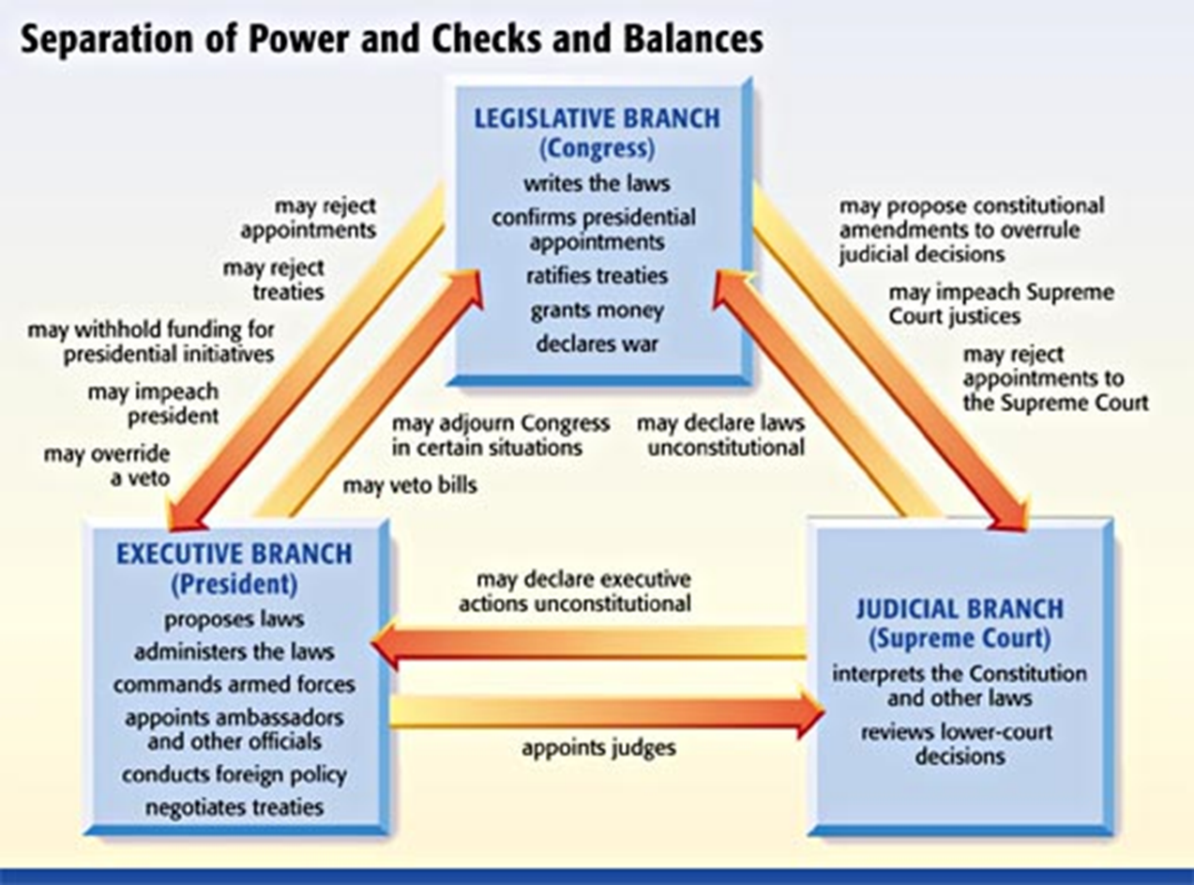

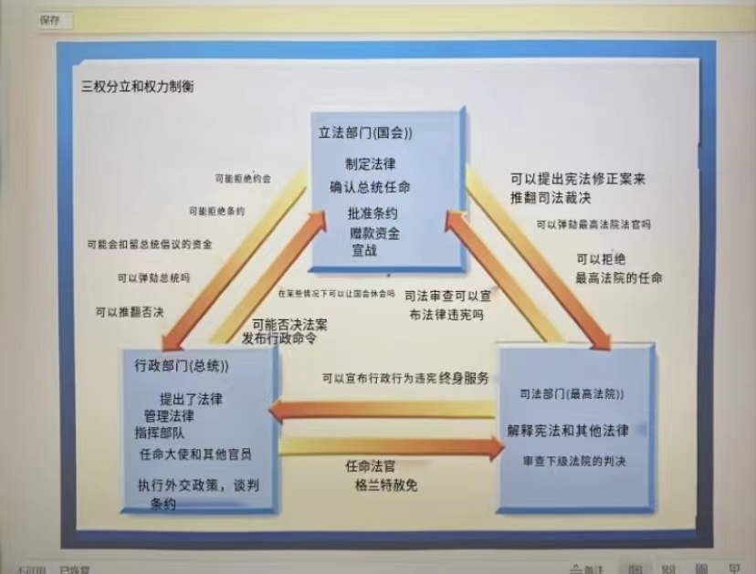

treaties条约；协定问题

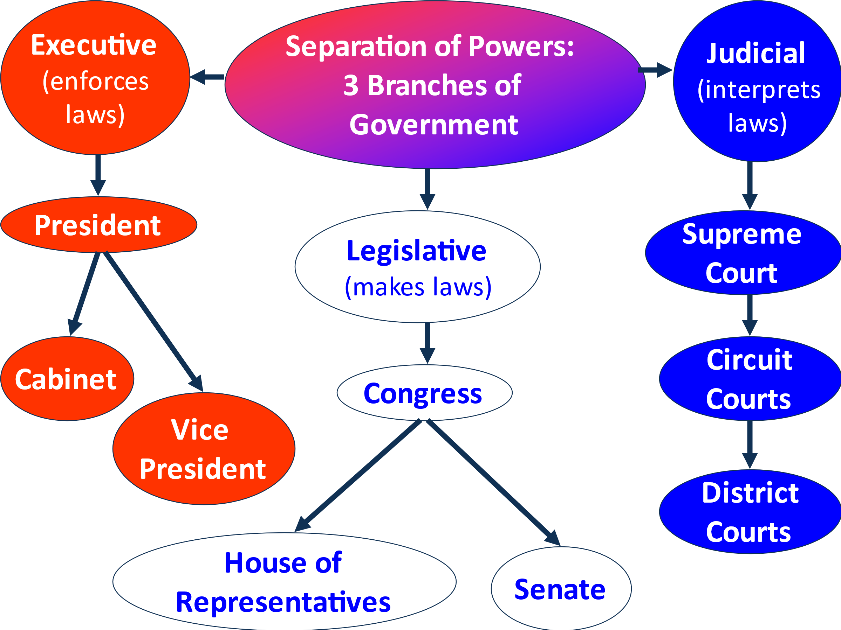

五、总统选举

What is the Electoral College?

538 electors = 435（House of Representative）+100（Senate）+3（Washington D.C

270 to win

plurality 最多数票

Popular votes 民选票

Electoral votes 选举人票

Election by people —— mob rule / tyranny of the majority人民选举——暴民统治/多数人的暴政

Election by congress—— too elitist, aristocratic国会选举——太精英化，贵族化

Electoral College as a compromise

wise, outstanding, educated, …—— peculiar, ritualized聪明的，杰出的，有教养的，…………特殊的，仪式化的

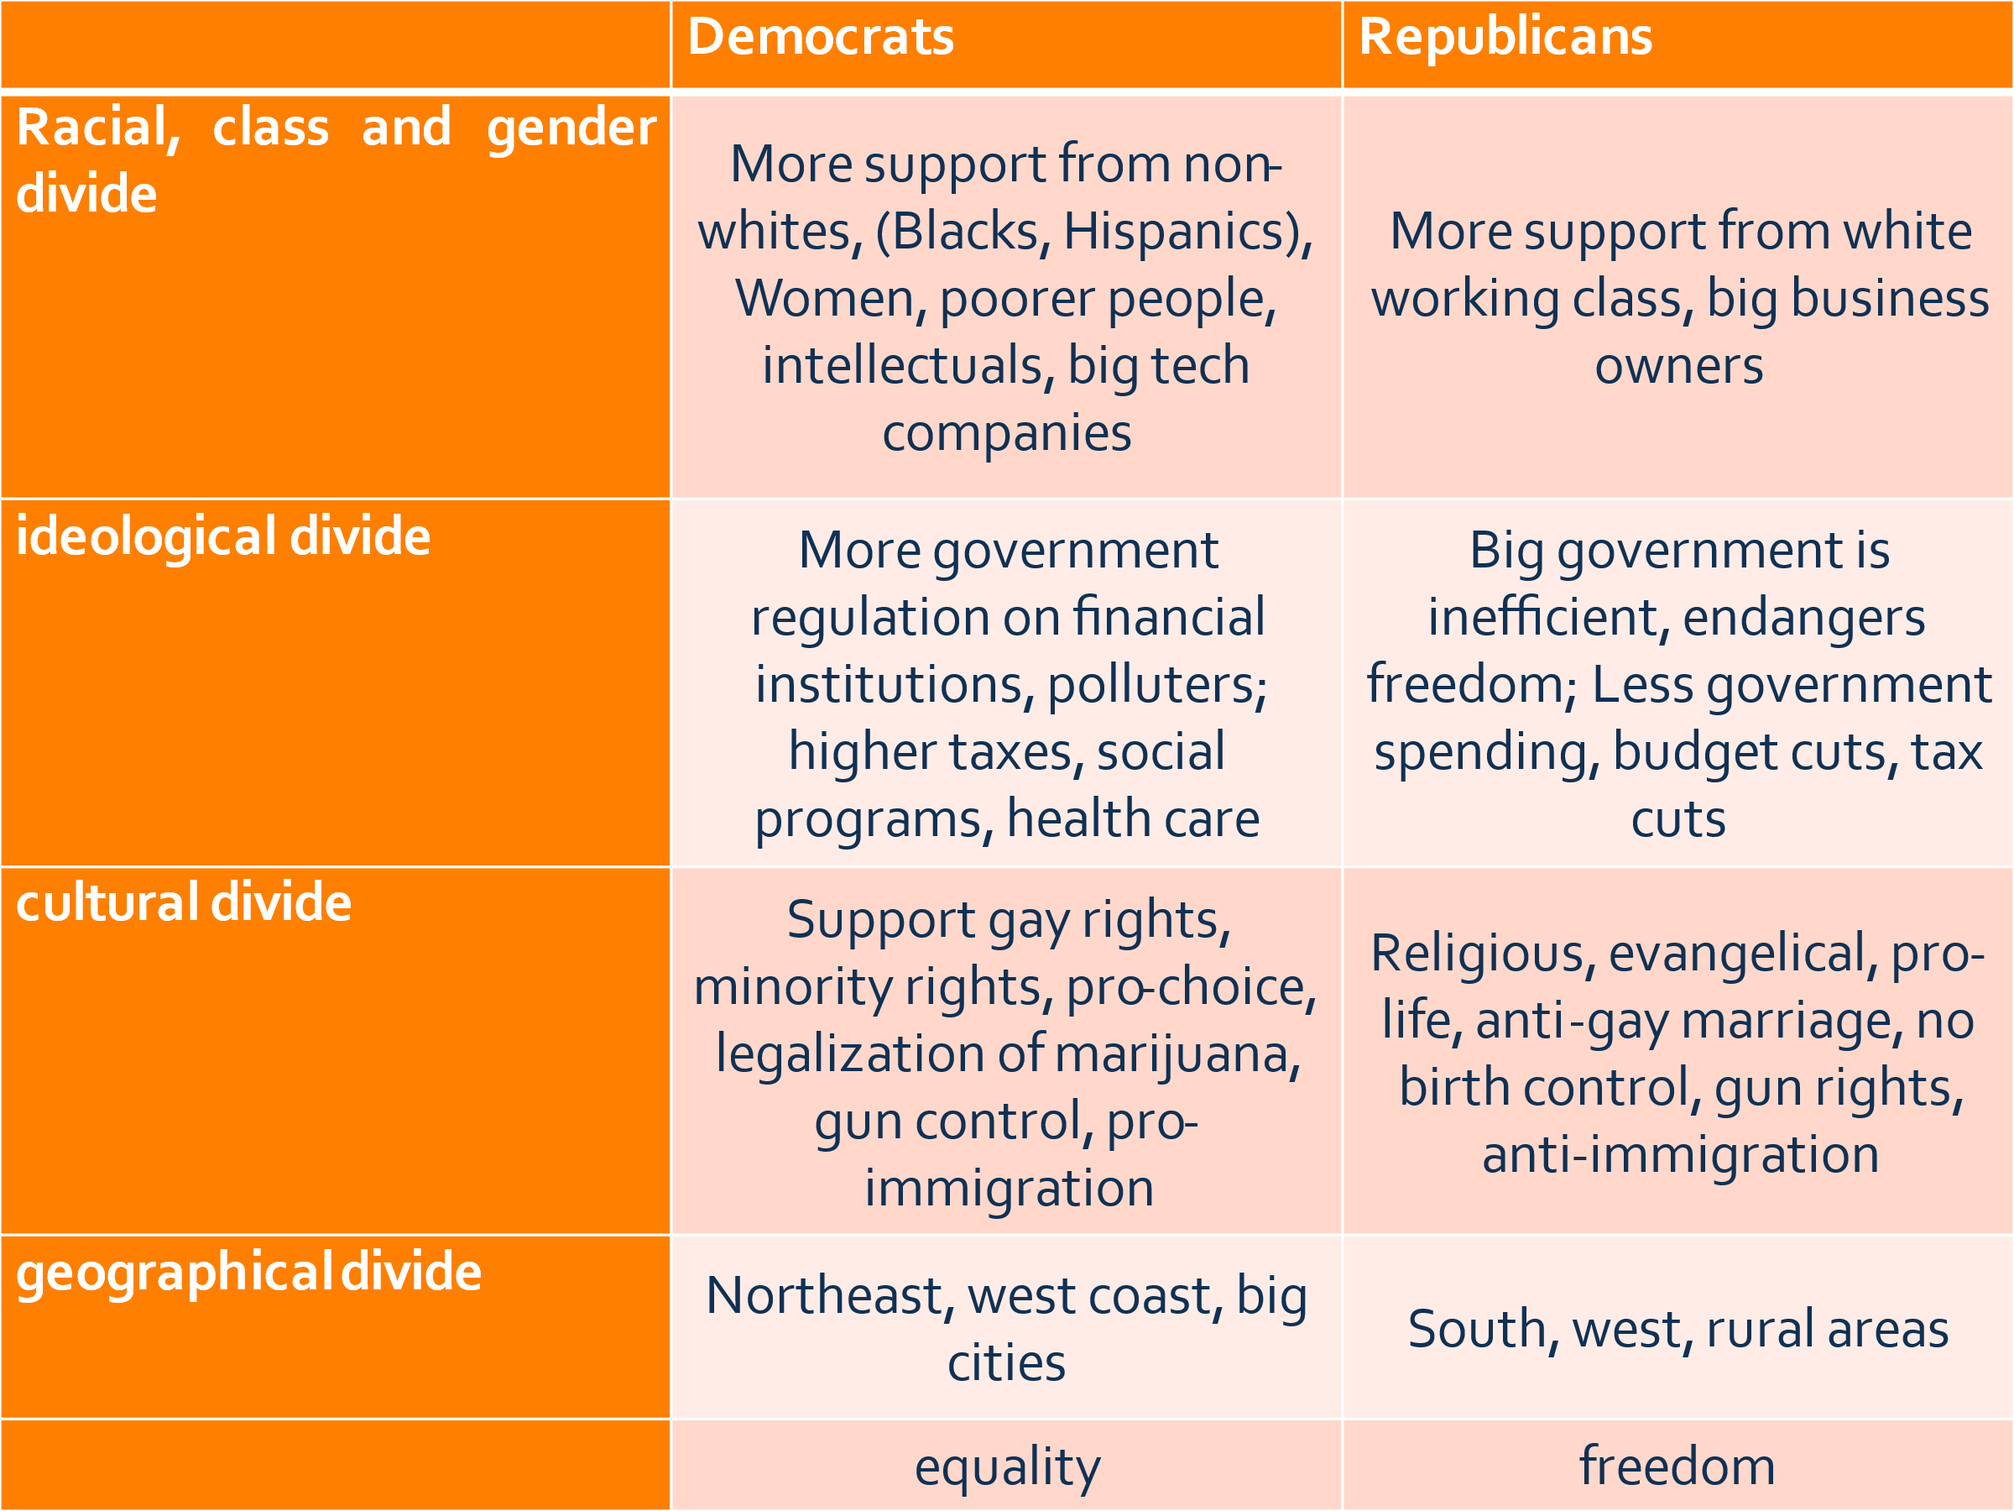

**差异：**

1.

民主党支持其它人种（黑人、西班牙人、女人、穷人）

共和党支持白人工薪阶层、企业家

2.

民主党主张政府管控、高税率、社会福利

共和党主张低政府管控、低政府开销（低社会福利）、减税

3.

民主党保护同性恋等少数群体权力、枪支管控、支持移民

共和党支持传统宗教、反对同性恋、支持持枪、反对移民

4.

民主党主要位于东北、西海岸、大城市

共和党主要位于南部、西部、乡村地区

5.

民主党主张平等

共和党主张自由

第六章Education in the United States

# 一、Great Importance Attached to Education

## （一）In the beginning

1. unusually high proportion of educated men among the first settlers第一批移民中受过教育的男性比例异常高(Male literacy rates are estimated at 80%-90% between 1650-1790)

2. a strong commitment to self-interpretation of the Bible对圣经自我解释的坚定

## （二）later

1. great leveler to erase artificial social distinctions消除人为的社会差异

2. great assimilator to Americanize immigrants使移民美国化的伟大同化者（回顾：美国化运动Americanization Movement，19世纪末至20世纪初美国政府发起的旨在使外来移民适应美国社会生活的教育运动。亦称“美国化”。）

## Quality of Public Schools（1825）：Bad

bad quality in general, according to the PISA results

Solutions: Federal government more involved with education联邦政府更多地参与教育

e.g.

Standards Movement

No Child Left Behind

Common Core

## American Higher Education

the Ivy League常青藤盟校

the financial situation of many college students——学费达到了家庭收入的很大比重

## Racial Equality and Education

Segregation: Separate but Equal (1896)种族隔离：隔离但平等

Desegregation of Schools (1954) 废除学校种族隔离The Supreme Court ended legal

segregation, but it continued

the Civil Rights Act (1960s)民权法

1970s: (at the college level) affirmative action: actively recruit minority students

少数⺠族配额problem：minority students with lower qualifications might be admitted instead of white students with higher qualifications- reverse discrimination学历较低的少数族裔学生可能会被录取，而不是学历较高的白人学生——这是反向歧视

### Residential Patterns Solidify School Segregation居住模式巩固了学校隔离

inner city内城区，穷人，黑人 vs. suburbs郊区，富人

the busing of schoolchildren校车接送学童

assistance programs for the neediest children为最贫困儿童提供的援助项目

## Education’s true goal: Intelligence PLUS character

## Educational ladder（阶段）: elementary and secondary education

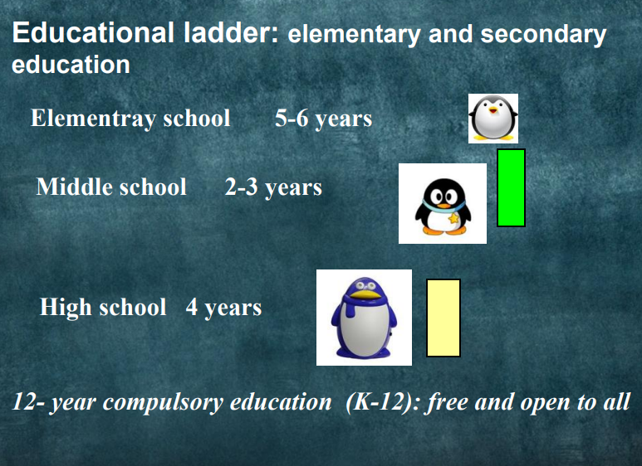

## Monetary value of Education

